Chapter 8: Reproducing

8.1 There are different ways of reproducing

Student worksheet answers (pages 140–141)

Reproduction

1 What is the difference between sexual and asexual reproduction?

Asexual reproduction involves a single organism making an exact genetic copy of itself; sexual reproduction combines genetic material from two organisms to produce a new organism

Asexual reproduction

2 What can be said of the genetic material between parent and offspring in asexual reproduction?

The genetic material is identical

3 What is binary fission?

When an organism splits in half to form two new organisms

4 What is parthenogenesis?

When unfertilised eggs hatch into new organisms

5 Give an example of an organism that undergoes parthenogenesis.

A reticulated python in a zoo that was isolated from other snakes

6 What is fragmentation?

When an animal is split in two and each half forms its own organism

7 Give an example of an organism that undergoes fragmentation.

A crown of thorns starfish

8 What is fragmentation in plants called?

Vegetative reproduction

9 What parts of a plant does the term in question 8 refer to? Give three examples.

Non-flower parts; for example, plantlets, stolons and rhizomes

Sexual reproduction

10 What is sexual reproduction?

When an egg from a female and sperm from a male join to form a gamete (offspring)

11 What is offspring?

The gamete that is formed from the fusion of egg and sperm, which has genetic material different from its parents

12 Why is variation within a population important?

For the survival of a species there must be genetic variation

13 What is the difference between identical and non-identical twins in terms of their DNA?

Identical twins have identical DNA; non-identical twins have different DNA

Hermaphrodites

14 What is a hermaphrodite?

An organism that has both female and male reproductive organs

15 Some organisms that are hermaphrodites can ‘turn off’ one sexual system. When and why would this be beneficial?

This would be beneficial when there are no organisms of the opposite sex. For instance, in a population of all males, the organism could become female and reproduce.

Extend your understanding

Hermaphroditism sometimes occurs in humans.

16 What tissues and organs must a human be born with in order to be a hermaphrodite?

Ovarian and testicular tissue; there may be an ovary underneath one testicle or the other, but more commonly one or both gonads contains both types of tissue

17 What happens in the fertilisation process for hermaphroditism to occur in humans?

Humans are usually XX (female) or XY (male). Hermaphrodites have a ‘normal’ genotype (XX or XY), but a mutation in some other gene causes the genitalia to form differently.

18 What is the more common and accepted term for a person who is a hermaphrodite?

Intersex

8.2 The female reproductive system produces eggs in the ovaries

Student worksheet answers (pages 142–143)

Female reproduction

1 Label the diagram of the female reproductive system below:

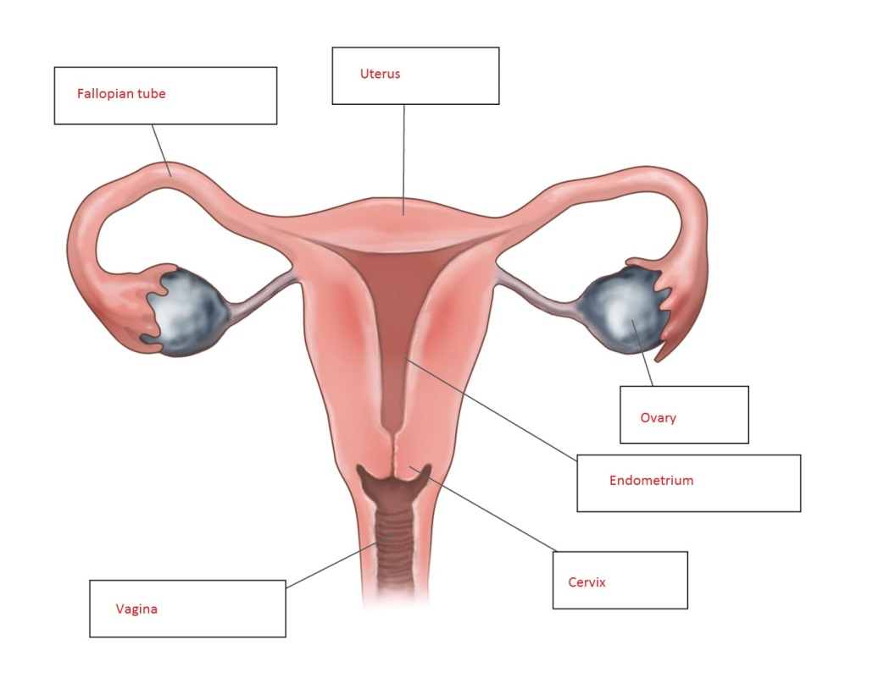

2 Match the organ involved in the female reproductive system to its function.

|  |  |
| --- | --- |
| **ORGAN** | **FUNCTION** |
| 1 Cervix | C Tissue at the entrance to the uterus that keeps a foetus in place while a woman is pregnant |
| 2 Vagina | F Canal between the cervix and the vulva |
| 3 Ovaries | B Contain egg cells |
| 4 Uterus | E Where a foetus develops until it is born |
| 5 Fallopian tubes | D Carry the egg into the uterus |
| 6 Egg | A Female reproductive cell |
| 7 Endometrium | G Lining of the uterus |

3 What is ovulation?

The process that occurs every month where a chemical messenger from the brain causes one egg to mature and be released from an ovary

4 Explain the function of oestrogen. What is the name for this type of chemical?

Oestrogen is responsible for causing the egg to mature; it is a hormone (chemical messenger)

5 What is the name of the organ that nourishes the baby?

Placenta

6 What is a gestation period?

The time it takes to grow and give birth to a baby; the human gestation period is 9 months

7 What is the average age that females first get their period?

Between 11 and 15 years, but may be earlier or later

8 On average, how long do menstrual periods last?

Around 5–7 days (see student book Figure 8.12)

Around 5–7 days (see student book Figure 8.12)

9 Explain the three stages of childbirth.

• Stage 1 – the uterus walls contract, which squeezes the baby down and causes the cervix to open

• Stage 2 – once the cervix is open 10 cm, the baby is pushed through the vagina

• Stage 3 – after the umbilical cord is cut, the placenta is delivered

Extend your understanding

Some women take an oral contraceptive (‘the pill’) to help regulate their mentrual cycle, avoid period pain and prevent pregnancy. The pill contains synthetic versions of oestrogen and progesterone, which females make naturally. The oestrogen stops the ovum from releasing the egg and the progesterone thickens the fluid at the opening of the cervix and stops sperm from getting through. Research oral contraceptives and answer the following questions.

10 Is it possible to become pregnant when having sex for the first time?

Yes

11 Explain how it may be possible for a female to become pregnant when they are taking an oral contraceptive.

Oral contraceptives are not 100% effective, especially if the pill is not taken at the same time every day or a dose is missed. Effectiveness is also reduced if combined with alcohol or antibiotics.

12 An oral contraceptive can be manufactured using only one of the hormones mentioned above. What is the benefit of using both hormones instead of just one?

The hormones work in different ways, therefore there are two forms of pregnancy prevention.

13 List other forms of contraception that either males or females can use to prevent pregnancy.

*Answer will vary.* Examples include the pill, condoms, spermicides, a diaphragm, female condoms, sponges, cervical caps, an IUD, implants, abstinence.

8.3 The male reproductive system produces sperm in the testes

Student worksheet answers (pages 144–145)

Male Reproduction

1 What is the difference between internal and external fertilisation?

Fertilisation of the egg with sperm can happen inside the organism (internal fertilisation) or out in the open (external fertilisation)

2 Explain what happens during fertilisation, mentioning all cells involved.

The male gamete (sperm) meets the female gamete (egg), and fuse to form offspring (zygote)

3 Where is sperm produced?

In the testes

4 Explain the function of testosterone. What is the name for this type of chemical?

Testosterone aids in sperm production, and many other functions; it is a hormone (chemical messenger)

5 Why is the scrotum outside of the body?

So that sperm can be kept below lower than 37ºC

6 Label the following diagram of the male reproductive system.

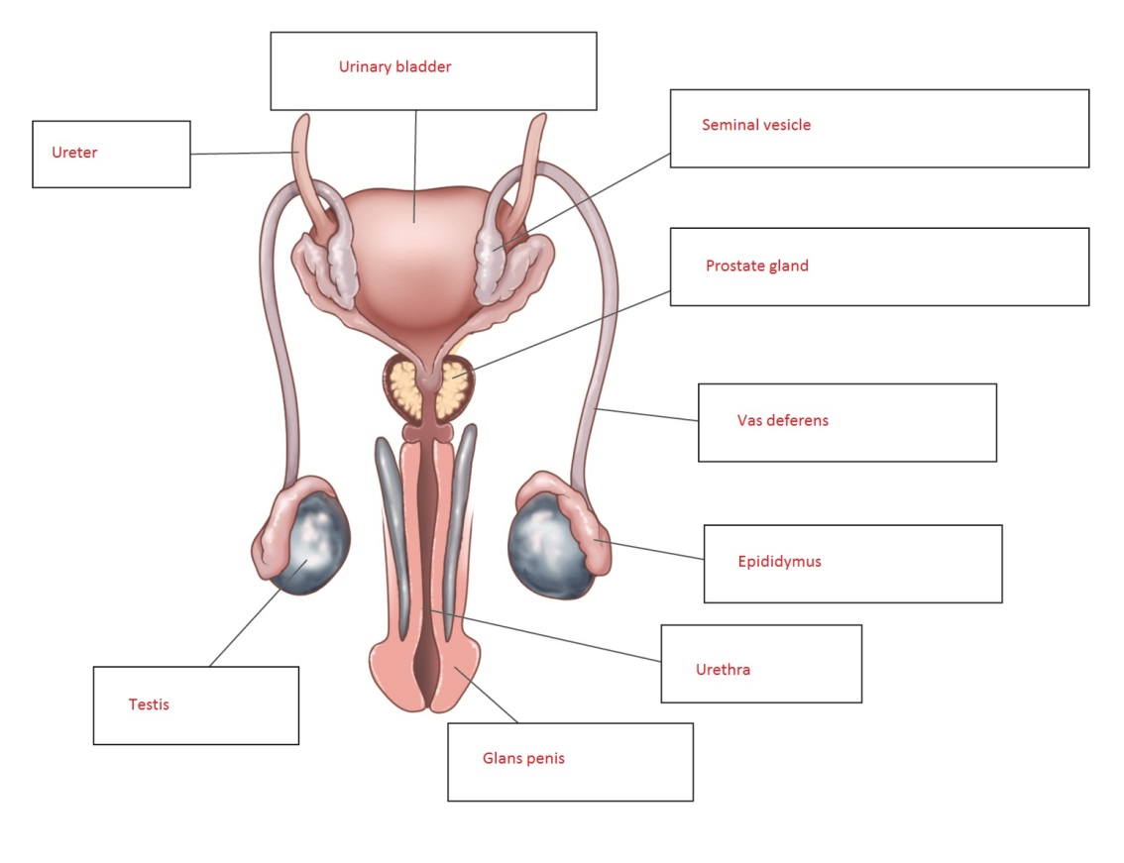

7 Match the organ involved in the male reproductive system to its function.

|  |  |
| --- | --- |
| **ORGAN** | **FUNCTION** |
| 1 Vas deferens | D Transports sperm from the testes to become semen |
| 2 Testes | E Produce sperm cells and the male sex hormones |
| 3 Penis | A An organ that swells with blood and stiffens during an erection |
| 4 Prostate gland | C A walnut-sized structure that blocks the flow of urine so that the sperm can be ejaculated out through the penis |
| 5 Urethra | F Carries semen or urine out of the body |
| 6 Sperm | B Male reproductive cell |
| 7 Seminal vesicles | H Small pouch-like structures that provide a fluid that is needed for the sperms’ journey |
| 8 Epididymis | G Where sperm mature |

8 There are two monotremes in the world and both are located in Australia. What are these two animals?

Platypus and echidna

9 What do birds, reptiles and monotremes have in common in their ability to reproduce?

They produce eggs

10 In comparison to humans, name three differences in the way that amphibians and fish reproduce.

External fertilisation; fertilisation occurs in water; hundreds of eggs laid at once

Extend your understanding

11 Complete the table below to compare human male and female reproduction (pages 140–145 of your student book).

|  |  |  |
| --- | --- | --- |
| **Characteristic** | **Male** | **Female** |
| Gamete | Sperm | Egg |
| Main hormone | Testosterone | Oestrogen |
| Organ that produces gamete | Testes | Ovary |
| Tubes that provide a pathway for the gamete | Vas deferens | Fallopian tubes |
| External genitalia (yes or no) | Yes (testes) | No |

8.4 Science as a human endeavour: Things sometimes go wrong in reproduction

Student worksheet answers (pages 146–147)

Problems in the reproductive system

Endometriosis

1 Which reproductive organ does endometriosis involve?

The uterus, but sometimes other organs such as the ovaries

2 What is the cause of endometriosis?

The endometrium (lining of the uterus) starts growing outside of the uterus, spreading to other organs

3 What are the effects of endometriosis?

Endometrial cells break down as normal once a month, which can be very painful when in organs other than the uterus. Also, scarring can prevent eggs being able to move down fallopian tubes, which can cause fertility issues

Human reproduction

4 What is ART?

Assisted reproductive technology – any procedure used to help a couple have a healthy baby

5 What is IVF? Explain the process.

In-vitro fertilisation. An egg is fertilised by sperm *in vitro* (in a test tube) and begins dividing as it is supposed to. The embryo is then transferred back into the mother’s uterus to go through a normal pregnancy.

6 What are the benefits of ART?

Allows couples with fertility issues to have a baby. Also, unborn babies can be screened for problems.

7 What are the potential risks involved with screening tests?

A needle must be inserted through the uterus to sample the amniotic fluid or cells of the placenta, which may cause infection or interfere with the pregnancy

Preserving biodiversity

8 Why is it important to stop species from becoming extinct?

Human rely on biodiversity for food, transportation and tourism. Species are also essential to the balance of ecosystems.

9 What is a captive breeding program?

The breeding of animals in zoos and sanctuaries in ideal environments, wether naturally or by IVF

10 What are the advantages of captive breeding programs?

Humans can control the environment, temperature, food and timing to increase the success of animals breeding

Contraception and desexing

11 What does contraception do?

Prevent pregnancy

12 What are the benefits of contraception in captivity?

Controls inbreeding; allows animals to be born at a time when there are enough resources and room

13 What is desexing? How is it performed?

A permanent contraceptive that involves either the vas deferens (males) or the fallopian tubes (females) being tied

14 What are the benefits of desexing animals?

Ensures there are less feral animals on the streets and that there are enough humans to care for the number of animals

Extend your understanding

15 Choose one of the three reproductive problems below and answer the following questions.

Fibroids Epididymitis Erectile dysfunction

|  |  |  |  |
| --- | --- | --- | --- |
|  | ***Fibroids*** | ***Epididymitis*** | ***Erectile dysfunction*** |
| a In which reproductive organ does the condition occur | Uterus | Epididymis | Penis |
| b What is the cause of this condition? | Tumorous growths on the uterus  Unknown cause, but believed to be hormone related as most commonly seen in pregnancy | An infection in the epididymis (series of small tubes attached to the back of the testes) when bacteria move from the urethra to the epididymis | This is a symptom of a bigger problem, either physical or psychological, e.g. too much alcohol, anxiety, tiredness |
| c What effects can this condition have on your body? | Heavy periods and prolonged bleeding | Slight fever, chills, sensitivity or a heavy feeling in the affected testicle, an enlarged testicle, discharge from the penis and abdominal pain | Inability to maintain an erection |
| d What is the treatment? | Medications to regulate hormones, surgery to remove tumors | Antibiotics to kill bacteria | Medications, counselling, injections into the penis, penile prosthetic implants |
| e Is there any way to manage the condition to avoid it happening again or to limit ongoing effects? | They must be monitored by a medical professional as there is no cure | No cure for chronic epididymitis.  Treatment to ease symptoms include baths, anti-inflammatory medication, nerve medication, muscle relaxant medication, surgery to remove the affected epididymis, stress management | Seek help from a medical professional, as the problem is usually ongoing |

8.5 Plant sexual reproduction produces seeds

Student worksheet answers (pages 148–149)

Sexual reproduction in plants

1 Label the reproductive organs of a flower on the diagram below.

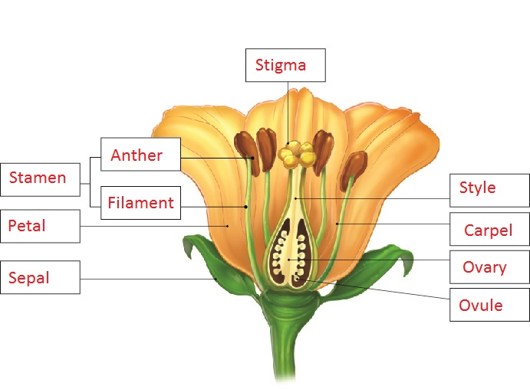

2 Match the organ in the reproductive system of a plant with its function.

|  |  |
| --- | --- |
| **ORGAN** | **FUNCTION** |
| 1 Stigma | D The ovum is located at the base of this organ |
| 2 Pollen | F Name of the male gamete |
| 3 Carpel | G Name of the three female parts together |
| 4 Ovary | A Name for the female egg |
| 5 Anther | B Organ located at the top of the male structure |
| 6 Ovum | C Organ where the female egg is produced |
| 7 Pollen tube | E Path that the pollen must follow to reach the ovary |

3 Label the structure of the carpel below.

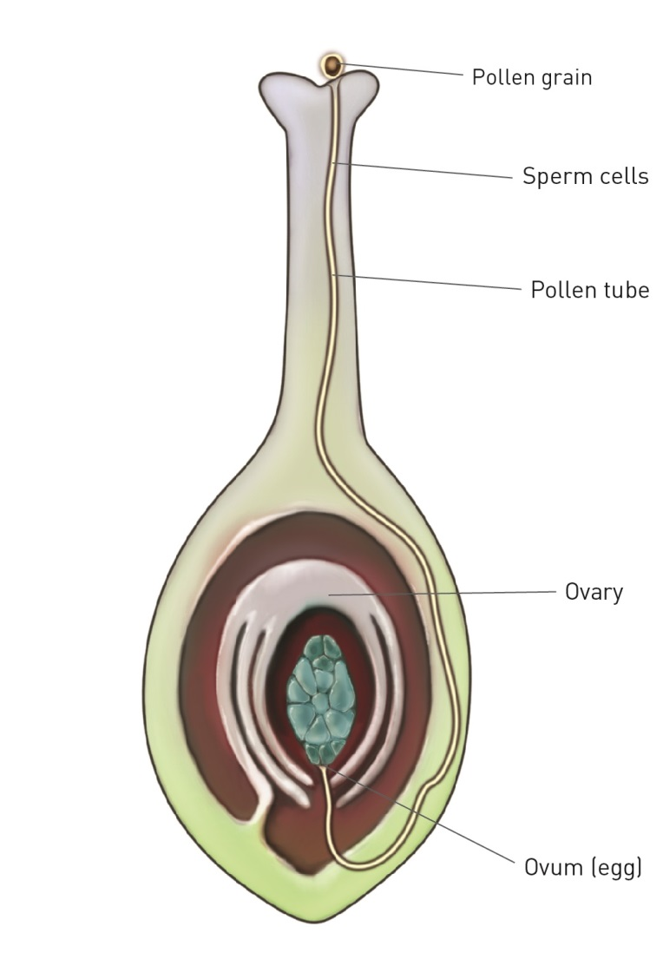

4 Name the three types of pollination and explain how each occurs.

Pollination – pollen attaches to the stigma and digs a pollen tube down to the ovary

Self-pollination – pollen from a flower lands on the stigma of the same plant

Cross-pollination – pollen from a flower lands on the stigma of a flower in a different plant

5 What are the benefits of a flower being colourful and having a strong smell?

Colour and odour attract pollinators that transfer pollen to other plants

6 What are spores?

Tiny reproductive structures that grow into plants with both male and female reproductive organs

7 How do ferns reproduce?

They produce spores and drop them to the ground when it rains to find a match for fertilisation

Extend your understanding

8 For each of the plants below, use what you have learnt to explain how each plant reproduces and how they attract animals to aid them in reproducing.

|  |  |
| --- | --- |
| Rafflesia | How does it reproduce?  Cross-pollination – animals transfer the pollen of one plant to the stigma of another plant  How does it attract animals?  Its smell attracts the animals that transfer the pollen; bright red colour attracts pollinators |
| Bottlebrush | How does it reproduce?  Cross-pollination – animals transfer the pollen of one plant to the stigma of another plant  How does it attract animals?  Its smell attracts the animals that transfer the pollen |
| Daffodil | How does it reproduce?  Cross-pollination – animals transfer the pollen of one plant to the stigma of another plant  How does it attract animals?  Its bright yellow colour attracts the animals that transfer the pollen |

8.6 Science as a human endeavour: Reproduction techniques have an impact in agriculture

Student worksheet answers (pages 150–151)

Selective breeding and its impacts

1 What is selective breeding?

When people choose the ‘partners’ of animals or plants so that they are specially bred to keep, lose or enhance certain characteristics

2 Why have sperm banks for animals been set up?

If animals have difficulty breeding, which may be due to geographical location or their owners wanting greater control over the animals they breed with, sperm banks may be set up for IVF or artificial insemination

3 Why is selective breeding used in plants?

People breed plants that are better able to survive conditions such as frost or disease; plants may be deliberately cross-pollinated with another type that produces high-quality grains to produce better quality plants

4 Give an example of one plant and two animals that are typically bred as a result of selective breeding.

Answers will vary. Examples may include wheat, orchids, carrots, cows, dogs and horses.

5 How can selective breeding lead to a loss of diversity in a population?

The amount of genetic material in a population decreases when you only breed plants and animals with particular characteristics. Thus, some traits are lost.

6 How does selective breeding put a population at risk of disease? Give an example.

Less variation in genetic material puts the whole population at an increased risk of disease. If one plant/animal contracts a disease, the more similar the genetic material, the greater the chance that another member of the population will contract the disease; Example – the Tasmanian devil with TDFTD (Tasmanian devil facial tumour disease)

7 What happened to potatoes in the mid-1800s as a result of lack of diversity?

A fungus wiped out potato crops across Ireland

8 What was the consequence of this potato event on the human population?

Approximately 1 million people died of starvation

9 What is inbreeding?

When animals reproduce with other animals to which they are closely related

10 What is the result of inbreeding within a population?

Lack of variation in genetic material and rare diseases showing up; for example, inbreeding has resulted in Labradors having hip problems

Extend your understanding

11 Inbreeding can cause numerous physical and behavioural problems in many animals. Research any three animals and explain some physical and behavioural issues that they face due to inbreeding.

Answers will vary.Examples may include:

|  |  |  |
| --- | --- | --- |
| **Animal** | **Physical Issues** | **Behavioural Issues** |
| Dogs | Lower immune system function; more infections and diseases  Hip dysplasia  Shorter life expectancy  Skin problems | Less intelligent  More aggressive, with behavior such as biting, chasing cars or other animals, escaping and playing too roughly |
| White Tigers | Cross-eyed  Short lifespan  Immune deficiency  Scoliosis of the spine  Cleft palettes  Bulging skulls | Less intelligent  More aggressive  Mental impairments |
| Humans | Expression of rare genetic disorders such as blindness, hearing loss, neonatal diabetes, limb malformations and schizophrenia  Increased deaths and shorter life span | Less intelligent  Developmental disabilities |